# Best Practices for Object Diagram

An **Object Diagram** represents instances of classes at a particular moment in time. It's crucial for understanding the state of the system and how objects are related.

#### **1. Keep it Simple and Focused**

* **Show only relevant objects**: Avoid overloading the diagram with too many objects. Only include those that are necessary to represent the scenario being modeled.
* **Limit the number of instances**: Focus on a subset of objects that represent a specific scenario or interaction.

#### **2. Use Clear Object Names**

* The object name should be clear and descriptive. It should represent the instance and sometimes its state (e.g., John_Student).
* Include the object's class name, followed by its current state (e.g., student1:name="John", grade="A").

#### **3. Show Important Relationships**

* Represent associations and references clearly by showing relationships between objects (e.g., Student has a Result).
* Use simple lines to show associations and arrows to represent dependencies.

#### **4. Consistency**

* Ensure that object names, attribute values, and the diagram’s layout remain consistent with other parts of your design.
* When using attributes in object instances, use consistent formats, such as showing the values in a specific format (<attributeName>:<value>).

#### **5. Avoid Redundancy**

* Don't repeat information that is already present in the Class Diagram unless necessary for the scenario.
* Object Diagrams should only depict the state of objects, not duplicate the class-level design.

# Best Practices for Class Diagram

A **Class Diagram** provides a static view of the system’s structure, representing classes, attributes, methods, and relationships.

#### **1. Keep it Simple and Abstract**

* Focus on **high-level** classes and avoid unnecessary details. Only include the attributes and methods that are essential for understanding the system's structure.
* Avoid overcomplicating with too many classes, especially in the initial stages of design.

#### **2. Use Meaningful Names for Classes and Attributes**

* **Class names** should be nouns that clearly describe the object or concept (e.g., Student, Course, Result).
* **Attribute names** should describe the characteristics of the object (e.g., studentId, email, grade).
* **Method names** should represent actions (e.g., enrollInCourse(), assignGrade()).

#### **3. Define Relationships Clearly**

* Clearly define the types of relationships between classes using appropriate UML notations:
  + **Association**: Represented by a simple line, indicating that classes are related.
  + **Inheritance**: Represented by a line with a triangle, indicating a superclass/subclass relationship.
  + **Aggregation/Composition**: Represented by lines with diamonds, denoting "whole-part" relationships (composition has a stronger relationship than aggregation).
* Use the right multiplicity (e.g., one-to-many, many-to-many) to describe how classes are related.

#### **4. Show Interfaces and Abstract Classes When Needed**

* If you're modeling interfaces, use the dashed line with a triangle pointing to the implementing class. This clarifies which class is fulfilling a contract.
* Abstract classes should be represented with italics or a clear indication that they cannot be instantiated.

#### **5. Use Proper Access Modifiers**

* Indicate whether attributes and methods are **public**, **private**, or **protected** (e.g., +, -, #).
* This helps clarify the visibility and encapsulation of each component in the class.

#### **6. Group Classes into Packages**

* In larger systems, group related classes into packages. This reduces clutter and improves readability.
* Use **packages** to logically group related classes (e.g., student, course, results).

# Best Practices for Sequence Diagram

A **Sequence Diagram** models the interaction between objects over time, focusing on the sequence of messages.

#### **1. Clear and Consistent Object Naming**

* The objects in the diagram should be clearly labeled with meaningful names. Use class names followed by object identifiers (e.g., Student1, Teacher_MrSmith).
* Use consistent naming conventions for messages, such as placeOrder(), enrollInCourse().

#### **2. Limit the Number of Objects in the Diagram**

* Too many objects can make the sequence diagram cluttered and hard to read. Limit the number of objects to only those essential for the particular scenario you’re modeling.
* If necessary, break complex interactions into smaller diagrams.

#### **3. Represent Lifelines and Activations Properly**

* **Lifelines** represent the existence of objects and are drawn as dashed vertical lines.
* **Activation bars** represent when an object is active and performing a task. Ensure that the lifeline’s activation bar is clearly defined for each method call.

#### **4. Use Clear and Meaningful Messages**

* Messages should clearly indicate what is happening between the objects. Use consistent naming conventions for method calls (e.g., getStudentResult() or calculateGrade()).
* Return messages should be dashed arrows, indicating that the method has completed and returned control or a value to the calling object.

#### **5. Ensure Proper Message Ordering**

* Messages in a sequence diagram should be drawn in **top-to-bottom** order to reflect the logical sequence of operations. The first message should appear at the top, followed by the subsequent messages.
* Use arrows to indicate the flow of communication, with clear labels for each message.

#### **6. Show Conditionals and Loops When Needed**

* If the flow depends on certain conditions, use **alt** (alternatives) or **opt** (optional) boxes to represent decision points or optional operations.
* For loops or repeated actions, use **loop** boxes and clearly show the repetition.

#### **7. Keep It Focused on a Single Use Case**

* Each sequence diagram should represent a single use case or scenario, making it easier to follow.
* Avoid combining multiple interactions in one sequence diagram. If a scenario has multiple branches or steps, create separate diagrams for each.

## 

## 

## **Sample Problem 1: School Results Application**

### **Class Diagram**

The class diagram represents the structure of a school results application where students have subjects, and their scores are calculated for grades.

**Diagram Description:**

* **Classes**: Student, Subject, GradeCalculator
* **Relationships**:
  + A Student has multiple Subject entries (Aggregation).
  + GradeCalculator computes the results for a Student.

### → Draw the Class Diagram

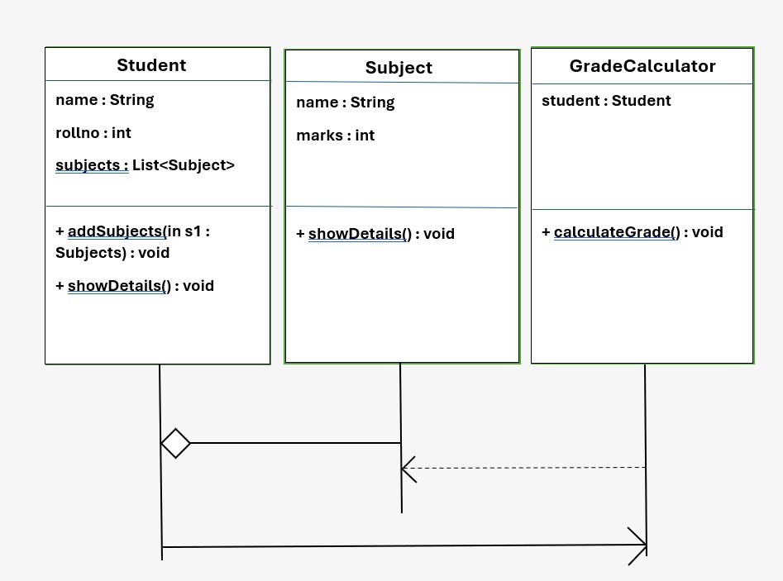

### **Object Diagram**

### An object diagram provides a snapshot of the Student and their Subject objects at a particular point.

**Example:**

* **Student**: John
* **Subjects**: Maths, Science
* **Marks**: 90, 85

### → Draw the Object Diagram

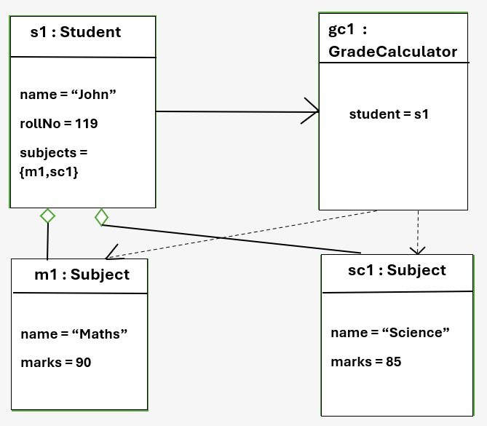

### **Sequence Diagram**

The sequence diagram shows how objects interact to calculate grades.

**Scenario:** A student requests their grade based on marks in subjects.

**Actors:**

1. Student
2. GradeCalculator

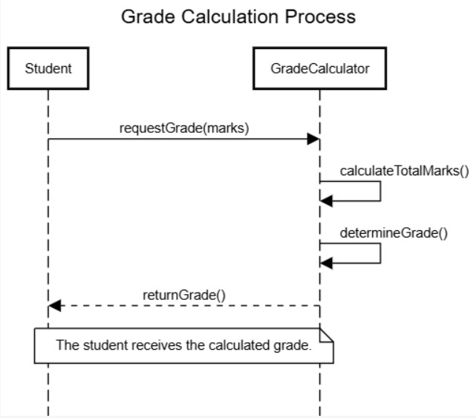

## **Sample Problem 2: Grocery Store Bill Generation Application**

### **Class Diagram**

The class diagram models the system where a customer buys products, and the bill is generated.

**Diagram Description:**

* **Classes**: Customer, Product, BillGenerator
* **Relationships**:
  + A Customer can purchase multiple Product items (Composition).
  + BillGenerator computes the total for the Customer.

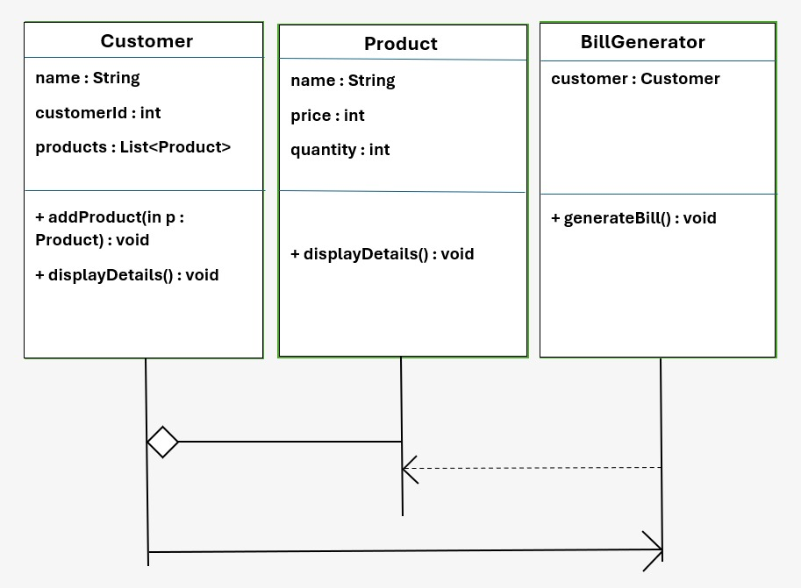

### **Object Diagram**

An object diagram shows the details of a Customer and the Product objects they have purchased.

**Example:**

* **Customer**: Alice
* **Products**:
  + Apples (2 kg at $3 per kg)
  + Milk (1 liter at $2 per liter)

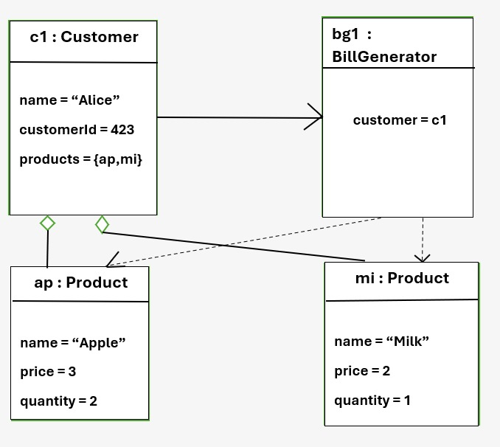

### **Sequence Diagram**

The sequence diagram shows the process of bill generation for a customer.

**Scenario:** A customer checks out at the grocery store, and the total bill is generated.

**Actors:**

1. Customer
2. BillGenerator

### → Draw the Sequence Diagram

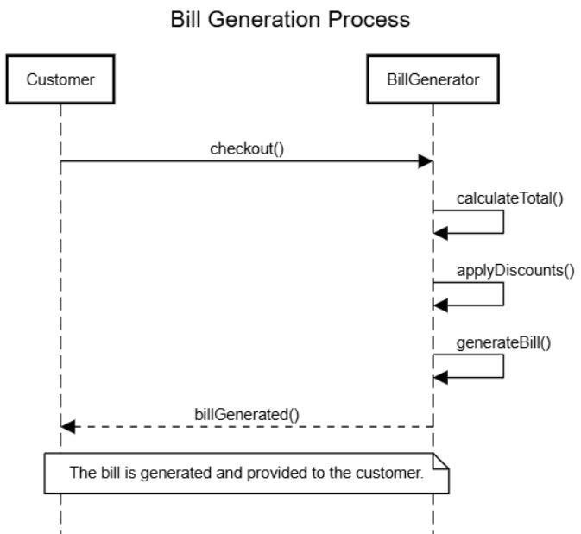

### **Comparison of the Two Scenarios**

| **Feature** | **School Results Application** | **Grocery Store Bill Application** |
| --- | --- | --- |
| **Classes** | Student, Subject, GradeCalculator | Customer, Product, BillGenerator |
| **Relationships** | Aggregation | Composition |
| **Primary Functionality** | Calculate grade | Generate total bill |
| **Key Entities** | Students, Subjects, Grades | Customers, Products, Bills |